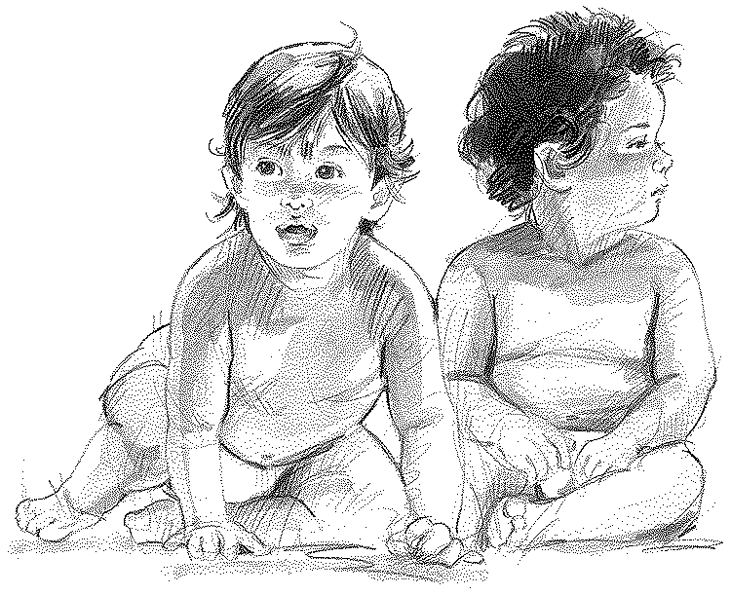
What is the Issue?

When is a baby a life?
1) Not When, but If
2) OT View
- Exodus 21:22-23 – “fruit” not limited to a certain time in womb
- Exodus 20:13 – Not to kill
3) Why
- Jeremiah 1:4-5 – God had plans for Jeremiah before he was born
- Psalms 139:13-16 – God “sees” in the womb (interest, concern)
- Genesis 1:26-27 – Made in God’s image (Value in all human life)
4) New Testament Agrees
- Acts 17:25 – God gives life
- Romans 13:9 – Not to kill

Women’s “body rights” (We accept various forms of right infringement)
1) Rights from our constitution: prostitution, seat belts, drink and drive, stop signs
2) Rights infringements under Christ: drinking, smoking, and the golden rule
- Matthew 7:12 – Golden rule
- 1Corinthians 6:6-10 – Sacrifice
- 1Corinthians 7:3-5 – Do not always have power over own body

Abortion Is a Moral Issue

Morals from God or Man?
1) The Contrast – Romans 1:20-32 – what happens when man makes his own rules
2) In Ages Past – Deut. 4:39-40 – God is the author law
3) Under Christ – 2Timothy 3:15-16 – all we need for guidance comes from God’s word.

